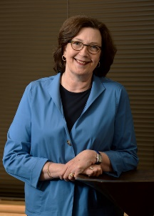
Press Release 9/9/20
For more information, please contact Vicki West at 512-658-8816

University Sales Center Alliance names Dr. Denise Smart, Texas State University as Outstanding Dean

The University Sales Center Alliance announces that Dr. Denise Smart, Dean of McCoy College of Business at Texas State University, has been named as the Outstanding Dean for 2020 by the University Sales Center Alliance. The USCA is a consortium of 58 member schools who work towards its mission of enhancing the sales profession through setting and monitoring university sales program standards, sharing best practices, enhancing sales curricula, and preparing students for the sales profession.

The USCA Outstanding Dean Award was established in 2019 to recognize a dean who has made significant contributions and demonstrated continued support of a USCA member’s sales program. Dean Smart’s efforts in establishing the Center for Professional Sales, securing resources for a Sales Lab, assuring that sales was included in a new data analytics graduate degree program, approving additional sales faculty, actively engaging with students, donors, sponsors and her continued guidance of the sales institute, clearly distinguished her as a valued supporter of sales education..

Dr. Andrea Dixon, President of USCA shared, “Dr. Denise Smart has faithfully served Texas State University for twenty years as their business school dean. To impact an institution as a leader for two decades is a feat that few accomplish. In addition to being a strong leader, Dean Smart has been a critical advocate for the work that Texas State has undertaken in the sales area. Due to her advocacy and her leadership, the Texas State sales program is viewed as one of the strongest in the country. She is incredibly deserving of receiving the USCA Outstanding Dean Award for 2020.”

Dean Smart’s “accomplishments only come from great leadership, passion and true grit” according to Elizabeth Terrell, VP Americas, Business Development at UPS. The Center for Professional Sales Director Vicki West further indicated that the dedication Dean Smart has exhibited for the past 20 years continues the upward trend of positive impact on the students at Texas State University.

To learn more about sales education, visit www.universitysalescenteralliance.org.
##

