For Immediate Release 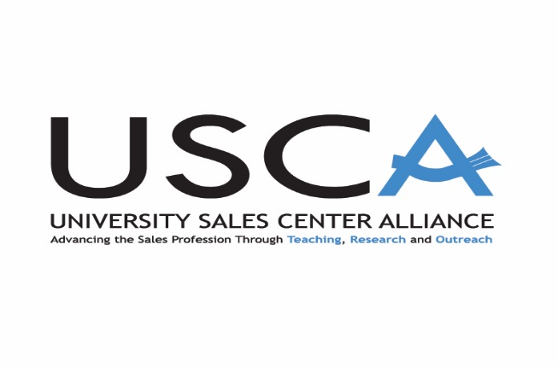
October 4, 2021
Local: Vicki West, Director – Center for Professional Sales
McCoy College of Business - Texas State University
512-245-3224
vw03@txstate.edu
Texas State University Hosts the University Sales Center Alliance 2021 Fall Conference
San Marcos, Texas – Over 60 sales center directors were hosted by the McCoy College of Business Center for Professional Sales September 30th through October 2nd, 2021. The attendees represented both fully accredited and associate members of the University Sales Center Alliance (USCA). United States universities represented included: Baylor University, Kennesaw State University, Kansas State University, California State University, The University of New Hampshire, and Florida State University, to name only a few. HAN University from Germany participated virtually and Ryerson University in Canada was represented in person. Both public and private universities are members of USCA. A complete list of members may be found at: www.universitysalescenteralliance.org
The mission of the University Sales Center Alliance is to advance the selling profession through setting and monitoring sales program standards, sharing best practices, enhancing sales curricula, and preparing students for a career in sales.
The USCA vision is to be recognized as the international leader and standard bearer for increasing the prestige and credibility of the sales profession.
Some of the meeting topics discussed at the conference were: Trends in Sales Management; Graduate Sales Education; The Membership and Reaccreditation process; and Managing Student Groups.
The keynote speaker for the conference was Ms. Amanda Campbell, Dell Technologies. Her presentation addressed the inside sales function and technology in professional selling.
Dr. Andrea Dixon, the Director of the Baylor Center for Professional Sales in the Hankamer School of Business, was the outgoing USCA President, and passed the gavel to Dr. Scott Inks, Co-Director of the Center for Professional Sales at Kennesaw State University.
Sponsors for meeting events were Rush Enterprises and Ferguson, Inc., both active partners with the Center for Professional Sales in McCoy College at Texas State University.
For additional information, please contact Vicki West, the Director of the Center for Professional Sales, at vw03@txstate.edu.

